
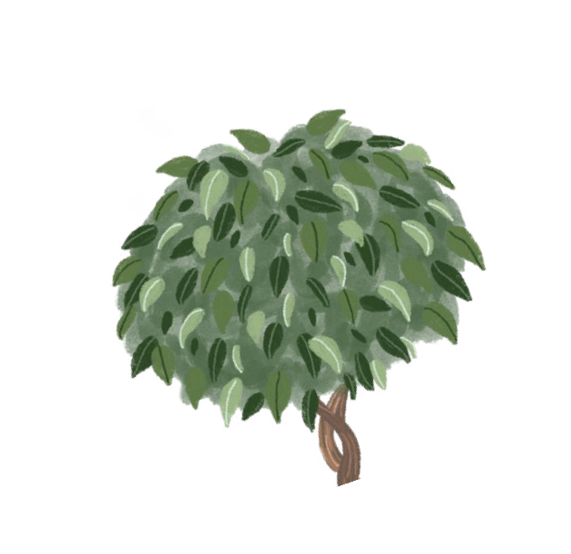









Read Within Your ZPD!
WHITE
BLUE
GREEN
ORANGE
YELLOW
PINK
RED
PURPLE
GOLD

1.0 - 1.9

2.0 - 2.9

3.0 - 3.4

3.5 - 4.0

4.1 - 4.5

4.6 - 5.0
5.1 - 6.0
6.1 - 7.9
8.0 -10.0

REGULAR READER
+ 1
READING RICHES
+ 3
MILLON WORDS/ OWN TARGET
+ 5

